Object-oriented programming Definition
Definitions of Object oriented programming

Structural definition.
OOP is a programming paradigm that organises software design around objects which are instances of classes.
These objects encapsulate data attributes and behaviour methods, allowing for modular and reusable code.

Behavioural Definition OOP is a methodology that enables the modelling of real-world entities as objects which can interact with each other through well-defined
This interaction is governed by the principles of encapsulation, inheritance and polymorphism.
OOP is a design philosophy that emphasises the use of objects to represent and manipulate data.
Functional definition.
OOP is a programming approach that focuses on the use of objects to structure and manage code.
It leverages concepts like encapsulation to protect data, inheritance to promote code reuse, and polymorphism to allow flexible and dynamic behaviour.
Educational perspective OP is a programming paradigm taught in computer science that uses objects and classes to create models of real-world systems.
It simplifies complex software development.
By breaking down problems into manageable interacting components, making it easier to understand, maintain and extend.

What is Class
A class is a blueprint or template for creating objects. It defines a set of attributes and methods that the created objects will have.
A class is a user-defined data type that serves as a blueprint for objects. It encapsulates data for the object and methods to manipulate that data.

class Car:
# Constructor method to initialize attributes
def __init__(self, brand, colour, max_speed):
self.brand = brand # Attribute
self.colour = colour # Attribute
self.max_speed = max_speed # Attribute

# Method to describe the car
def describe(self):
print(f"This is a {self.colour} {self.brand} car with a top speed of {self.max_speed} km/h.")

# Method to simulate driving
def drive(self):
print(f"The {self.colour} {self.brand} is now driving.")

What is an Object?
An object is an instance of a class. It represents a specific implementation of the class, containing real values instead of variables.
An object is a self-contained entity that consists of both data and procedures to manipulate the data. It is created from a class and represents a specific instance of that class.
# Creating objects from the Car class
car1 = Car("Toyota", "red", 200)
car2 = Car("BMW", "blue", 240)
Summary of the examples above:
Class: Car (defines a blueprint for creating car objects).
Objects: car1 (a red Toyota), car2 (a blue BMW).

What is Encapsulation?
Encapsulation is the bundling of data (attributes) and methods (functions) that operate on the data into a single unit (class).
It also involves restricting direct access to some of an object's components, achieved by using access modifiers like private, protected, and public, which is a way of preventing unintended interference and misuse of the data.

Example of encapsulation:
class BankAccount:
def __init__(self, balance):
self.__balance = balance # Private attribute

def deposit(self, amount):
if amount > 0:
self.__balance += amount

def get_balance(self):
return self.__balance

account = BankAccount(100)
account.deposit(50)
print(account.get_balance()) # Output: 150
# account.__balance # This would raise an error because __balance is private

What is Inheritance?
inheritance allows a class (child class) to inherit attributes and methods from another class (parent class). This promotes code reuse and establishes a hierarchical relationship. It supports the creation of a new class that is based on an existing class, extending its functionality. This promotes code reuse and establishes a relationship between the parent and child classes.
DiscountBook in code below is child class of Book.
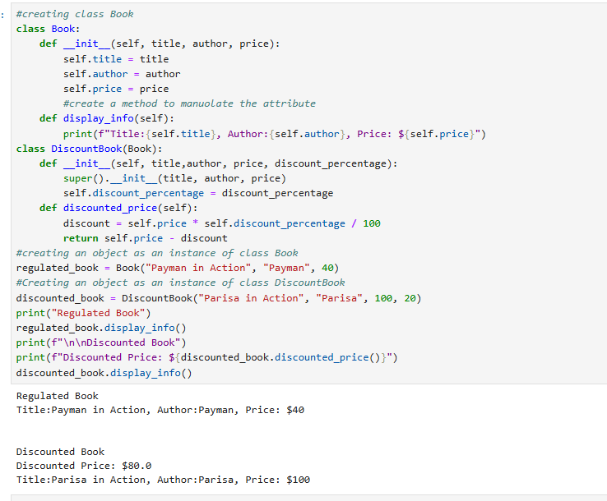
What is Polymorphism
Polymorphism allows objects of different classes to be treated as objects of a common super class.
It enables a single interface to represent different underlying forms (data types).
This concept is often implemented through method overriding and method overloading.
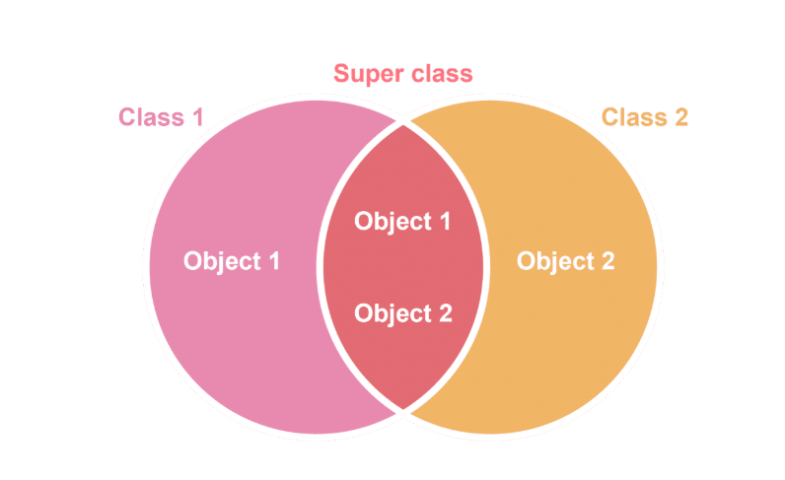Abstraction
Abstraction involves hiding the complex implementation details and showing only the necessary features of an object. It helps in reducing programming complexity and effort. Abstract classes and interfaces are used to define a clear and simple interface for interacting with objects.
P• ABC: Stands for Abstract Base Class—used to define a class that should not be directly used.
- abstractmethod: Marks a method that must be implemented by any subclass.

from abc import ABC, abstractmethod

• Shape is an abstract class.
- It says: “Any shape must have an area() method.”
- pass means “do nothing for now”—it’s just a placeholder.

class Shape(ABC):
@abstractmethod
def area(self):
pass
• Circle inherits from Shape.
- It adds a radius attribute when you create a circle.

class Circle(Shape):
def __init__(self, radius):
self.radius = radius

Implement the Required Method
- This is the actual formula for the area of a circle: π × r².
- Now Circle satisfies the abstract requirement from Shape

def area(self):
return 3.14 * self.radius * self.radius

circle = Circle(5)
print(circle.area()) # Output: 78.5
for creating car objects).
Objects: car1 (a red Toyota), car2 (a blue BMW).

